CAON’s Annual African American Read -In

CAON invites you to celebrate

Black History Month

by reading African-American literature to our students.

Join us as part of the Twenty-Seventh National African American Read-In.
Please email or call for more information or to RSVP....
314-241-1110 x1122
Ashley.Rhodes@confluenceacademy.org

Date: Tuesday 02/28/2017
Time: 8:30am-10:00 am
Where: Confluence Academy-Old North’s Gymnasium
Who: The Friends of Confluence

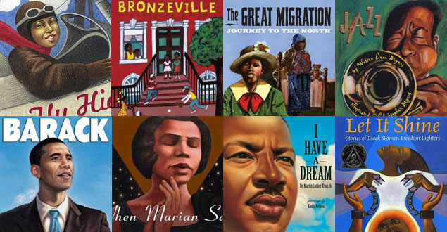
"Once you learn to read, you will be forever free." — Frederick Douglass

